University of Regina

ENSE 400/477



**Project Night Terror**



*Author: Advisor:*

Evan Geissler Dr. Christine Chan

200331033



Last Modified

March 30, 2019

**Revision History**

**Revision Version Date**

Version 1 March 30, 2019

**Table of Contents**

**1 Requirements & Specifications………………….………………….…......1**

**1.1 Introduction………………………………………………………………………………….…......1**

1.1.1 Purpose.............................………………………………..………………..........………....…1

1.1.2 Scope........................................……………..…………………………………….........…...…1

1.1.3 Main Objectives and Success Criteria……….………………..............................…1

1.1.4 Secondary Objectives..…………...........................................………….........…........…2

1.1.5 Constraints..…………................................................................………….........…........…3

1.1.6 Overview..………….......................................................................………….........….....…3

**1.2 Proposed Project..........………….………………...…………….....……………………………3**

1.2.1 Functional Requirements.………………...…………….........………………........……3

1.2.2 Non-functional Requirements.………………...……………..........…………….........4

1.2.3 Software Requirements.………………...…………….....………...…………………….4

1.2.4 System Models.………………...…………….....……………………….....….................…5

**2 System & Object Design…………………………………………….…......1**

**2.1 Introduction………………………………………………………………………………….…......1**

2.1.1 Purpose.............................………………………………..………………..........………........1

2.1.2 System & Component Overview……………………..………………..........…….......1

**2.2 Class Diagrams..........………….………………...…………….....……………………………....1**

2.2.1 Purpose.............................………………………………..………………..........………........1

2.2.2 Characters…………………………………………………...................................................2

2.2.3 Pickups………………………………………………….........................................................3

2.2.4 Weapons…………………………………………………......................................................4

**2.3 Flow Chart Structures......……….………………...…………….....………………………….4**

2.3.1 Purpose.………………...…………….....………………........…….......................................4

2.3.2 General Game Flow.………………...…………….....………………........……................4

2.3.3 Demon Behaviour State Flow.………….…………….....………………........…….....5

2.3.4 Ghost Behaviour State Flow.………………...…….....………………........…..........…6

2.3.5 Saving & Loading.………………...…………….....………………........…….....................7

**2.4 Perk Trees..........……….…………...…………….....……………………………......................8**

2.4.1 Purpose…………………………………………………........................................................8

2.4.2 Health…………………………………………………............................................................9

2.4.3 Flashlight…………………………………………………..................................................10

2.4.4 Pistol…………………………………………………...........................................................11

2.4.5 Rifle………………………………………………….............................................................12

**2.5 Blend Spaces..........……….…………...…………….....……………...............………………12**

2.5.1 Purpose…………………………………………………......................................................12

2.5.2 General Blend Space…………………………………………………............................13

**2.6 State Machines..........……….…………...…………….....……………………............………14**

2.6.1 Purpose…………………………………………………......................................................14

2.6.2 Main Character………………………………………………….......................................14

2.6.3 Demon Characters…………………………………………………................................17

2.6.4 General Ghost………………………………………………….........................................18

2.6.5 Main Ghost…………………………………………………...............................................18

**3 Test Plan & Execution**

**3.1 Introduction………………………………………………………………………………….…......**

3.1.1 Purpose.............................………………………………..………………..........………....

3.1.2 Things to Test...................................……………………………………….........…...…

3.1.3 Test Level...................................……………………………………….........…...…

**3.2 Usability Testing..........………….………………...…………….....……………………………**

3.2.1 Purpose & Breakdown………...…………….....………………........……

3.2.2 Demographics.………………...…………….....…………….........

3.2.3 Testing Results.………………...…………….....…………………………….

3.2.5 User Feedback.……………...…………….....………………………….................…

**3.3 White Box Testing..........……….………………...…………….....……………………………**

3.3.1 Purpose & Breakdown.………………...…………….....………………........……

3.3.2 Tests Performed.………………...…………….....…………….........

**3.4 Black Box Testing..........……….………………...…………….....……………………………**

3.4.1 Purpose & Breakdown.………………...…………….....………………........……

3.4.2 Tests Performed.………………...…………….....…………….........

**3.5 Automated Testing..........……….…………...…………….....……………………………**

3.5.1 Purpose & Breakdown.………………...…………….....………………........……

**4 Business Plan**

**5 How-To-Use**

**5.1 Introduction………………………………………………………………………………….…......1**

5.1.1 Purpose.............................………………………………..………………..........………........1

**5.2 Hardware Specifications..........….……………...…………….....…………………………..1**

5.2.1 System Requirements …………………………………………………...........................1

**5.3 Gameplay Menus......……….……...…………….....…………………………….....................1**

5.3.1 Menus.………………...…………….....………………........……...........................................1

5.3.2 Objectives Menu.………………...…………….....………………..............................……3

5.3.3 Items Menu.………………...…………….....………………........……................................4

5.3.4 Collectables & Other Pickups.………………...…….....………………........…........…5

5.3.5 Perks Menu.………………...…………….....……………................................…........……6

**5.4 Normal Gameplay....………………...…………….....……………………………...................7**

5.4.1 Button Mapping.………………...…………….....………………...............................……7

5.4.2 Attacking.………………...…………….....………………........…….....................................8

5.4.3 Saving & Loading.………………...…………….....………………........….....................…8

5.4.3 HUD.………………...…………….....………………........……...............................................8

**5.5 Startup & Exiting......…………………...…….....…………………………….........................9**

5.5.1 Starting the Game.………………...…………….....………………........……...................9

5.5.2 Exiting the Game.………………...…………….....………………........…….....................9

**6 Log Book**

**7 Future Works**

**8 Conclusion**

**List of Figures**

Figure 1.2-1. Basic Flowchart of the Game…………………………………………………...............5

Figure 1.2-2. Character Class Diagram………………………………………………….......................5

Figure 1.2-3. Collectable Class Diagram…………………………………………………....................6

Figure 1.2-4. Weapon Class Diagram……………………………………….………............................7

Figure 1.2-5. Example of Perk Trees……………………………………….……….............................7

Figure 1.2-6. Basic HUD…………………………………….........……………………………………..........8

Figure 1.2-7. Main Menu…………………………………….........……………………………………........8

Figure 1.2-8. Item Menu…...………………………………….........……………………………………......9

Figure 1.2-9. Pause Menu…………………………………….........……………………………………......9

Figure 2.1-1. Component Overview.....………………………………………………….......................1

Figure 2.2-1. Character Class Diagram………………………………………………….......................2

Figure 2.2-2. Pickup Class Diagram………………………………………………….............................3

Figure 2.2-3. Weapon Class Diagram……………………………………………….............................4

Figure 2.3-1. Basic Flowchart of the Game……………………………………….............................5

Figure 2.3-2. Demon Flowchart………………………………………...................................................6

Figure 2.3-3. Main Ghost Flowchart………………………………………..........................................7

Figure 2.3-4. General Ghost Flowchart………………………………………....................................7

Figure 2.3-5. Loading Flowchart……………………………………….................................................7

Figure 2.3-6. Saving Flowchart………………………………………....................................................8

Figure 2.4-1. Perk Tree Example …………………….........…………………………………….............8

Figure 2.4-2. Health Perk Tree…………………….........……………………………………..................9

Figure 2.4-3. Flashlight Perk Tree…………………….........…………………………………….........10

Figure 2.4-4. Pistol Perk Tree…………………….........……………………………………..................11

Figure 2.4-5. Rifle Perk Tree…………………….........……………………………………....................12

Figure 2.5-1. General Blend Space Graph………………..........………………..............................13

Figure 2.6-1. Main Character Main State Machine………………..........……………................15

Figure 2.6-2. Main Character Walk-Run Sub State Machine………….......……………........15

Figure 2.6-3. Main Character Rifle & Pistol Sub State Machine………….......……….........16

Figure 2.6-4. Main Character Cross & Knife Sub State Machine ………….......…………...17

Figure 2.6-5. Demon State Machine………………..........……………….........................................17

Figure 2.6-6. General Ghost State Machine………………..........………………...........................18

Figure 2.6-7. Main Ghost State Machine………………..........……………….................................18

Figure 3.1-1. Entire Testing Level…………………………………………………...............

Figure 3.1-2. Test Level: Character & Light Areas……………………………….......................

Figure 3.1-3. Test Level: Collectables & Modified Atlantic Wall Areas…..................

Figure 5.3-1. Main Menu…………………………………….........…..................................................1

Figure 5.3-2. Pause Menu……………………………..….........……..................................................2

Figure 5.3-3. In Game Menu………………………...………………….............................................3

Figure 5.3-4. Objectives Tab with Main Objectives Selected…........................................3

Figure 5.3-5. Items Tab with Flashlight Selected…………….....……...........................4

Figure 5.3-6. Collectable Pickup Prompt……………………...................................................5

Figure 5.3-7. Artifact Menu Before Selecting Artifact 4………..........................................5

Figure 5.3-8. Artifact Menu After Selecting Artifact 4………..............................................6

Figure 5.3-9. Perk Menu……………….....………………….........................................................6

Figure 5.4-1. HUD with Flashlight & Rifle Equipped……...................................................9

**List of Tables**

Table 1.2-1. Shooting a Weapon……………….....…………………………………………………......3

Table 1.2-2. Picking Up an Item or Collectable…......…………………………………………......3

Table 1.2-3. Saving & Loading…………………………..............................................……………......4

Table 1.2-4. Head Up Display…......…………….....................…………………………..............…......4

Table 1.2-5. Menus…......…………….....................……....................……………………..............…......4

Table 2.5-1. General Blend Space Points……………….....…………………………………….....14

Table 5.4-1. Button Mapping……………….....………………………………………………….............7

**Appendices**

**A Usability Tests…………………………………………………………………………….…......**

**B White Box Tests………………………………………………………………….…......**

**C Black Box Tests…………………………………………………………………………….…......**



**Section 1 Requirements & Specifications**



**1.1 Introduction**

**1.1.1 Purpose**

The purpose of this project is to create a twisted, scary, and enjoyable gaming experience in a first person perspective.

**1.2.1 Scope**

**In Scope**

This project will have two non-playable characters (NPCs); one that guides the player and one that is the main antagonist. Along with these two, there will be enemy NPCs that will challenge and/or attack the player and passive ghost NPCs. The enemy NPCs will consist of at least 3 different demon characters that are all affected by light to some degree. The NPCs will also have varying levels of AI depending on their purpose.

The playable area will be a landscape similar to Qu’Appelle Valley, Saskatchewan and will also include interiors and/or exteriors of popular haunted buildings inspired by different areas in Qu’Appelle Valley.

The game will have items such as a gun, flashlight, or cross. These are used to defeat enemies and aide the player. These items and the player’s health will be upgradable by finding collectables in different areas.

Also in the scope of the project will be dynamic menus, i.e. menus that change, as the player progresses and also the ability to save the game. Music and sound effects will be added to enhance the over experience. Sub objectives will also be used to add to the story and add a means of getting an upgrade. The story will be told by NPCs, collectibles, etc. The collectibles will be audio files, letters, items, etc.

Finally, accessibility options will also be added to allow for subtitles, brightness changes, speed of the playable character, etc. to allow for a user-friendlier gameplay.

**Out of Scope**

This project will not include any form of multiplayer. The project will also have a limit on quality of graphics, number of assets, in depth voice acting, sound track, etc.

**1.1.3 Main Objectives and Success Criteria**

1. Realistic Landscape & Environmental Creation
   1. Key buildings with interiors and/or exteriors
   2. Qu’Appelle Valley area
2. Two main Non-Playable Characters (NPCs)
   1. Passive ghost (guides player)
   2. Mostly passive demon (main antagonist)
   3. Multiple NPC with Varying AI
   4. Passive NPC mostly minimum AI (walking around, etc.)
   5. Various Enemy AI levels (Attacks, abilities, etc.)
3. Dynamic menus such that it changes as player progresses Ex. Main Menu environment changes from sunny to stormy
4. Multiple items (flashlight, pistol, etc.)
5. Upgradable Items
   1. Optional (Can complete game without them)
   2. Usually obtained in side objectives
   3. 0 to 3 upgrades per item
6. The ability to save progress and return to that point without penalty
7. Start to Finish Aspects
   1. Main menu
   2. Opening
   3. Main Game
   4. Credits
   5. Some Music & Sound Effects
8. Collectables
   1. Letters, texts, messages, etc.
   2. Objects that relate to area
9. A set of main and side objectives

**1.1.4 Secondary Objectives**

1. Easter eggs & references
2. Trophies, achievements, etc.
3. Create a multiplatform game, i.e. for Xbox One, PS4, etc.
4. New game+ (second play through)
   1. Harder and different NPC AI
   2. Level changes
5. Complete Set of Music & Sounds
6. Voice Acting
7. More Items
8. Better Details
   1. Environment (Nicer grass, water, etc.)
   2. Items (Intricate design)

**1.1.5 Constraints**

Constraints of the project include time to complete tasks, having to learn new or more in-depth tools, money, etc. To limit strain of constraints the project will be designed while also watching tutorials, using free programs, using easy to use programs, and using helpful software.

**1.1.6 Overview**

Project Night Terror is a first person realistic horror game that will allow players to experience a story driven game from start to finish. The player will be able to find collectables, items, and different leveled non-playable characters. The game is based around ghost stories, real locations, and/or fictional events in Saskatchewan.

**1.2 Proposed Project**

**1.2.1 Functional Requirements**

***Table 1.2-1. Shooting a Weapon***



***Table 1.2-2. Picking Up an Item or Collectable***



***Table 1.2-3. Saving & Loading***



**1.2.2 Non-functional Requirements**

***Table 1.2-4. Heads Up Display***



***Table 1.2-5. Menus***



**1.2.3 Software Requirements**

The only main requirements needed for the project is an easy to use game engine. For this project, Unreal Engine 4 will be used.

**1.2.4 System Models**

**Scenarios**



***Figure 1.2-1. Basic Flowchart of the Game***

**Object Model**



***Figure 1.2-2. Character Class Diagram***



***Figure 1.2-3. Collectable Class Diagram***



***Figure 1.2-4. Weapon Class Diagram***



***Figure 1.2-5. Example of Perk Trees***

**User Interfaces & Menus**

This section gives a brief overview of the different user interfaces (UI) and menus the player will encounter.

The head up display (HUD) is what the player will see during most of the game, as it will be the information shown as they are playing the actual game. This includes health information, item information, and a motion sickness/aiming dot.

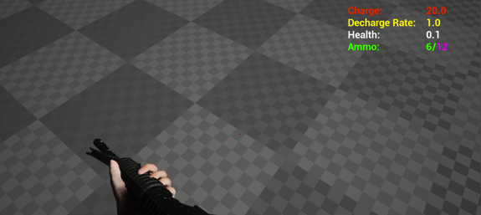

***Figure 1.2-6. Basic HUD***

The main menu is what the player will first see when the game is opened. The menu will allow the player to play a game from the start, load a saved game, delete a saved game, change settings, and exit the game.

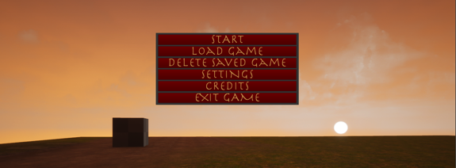

***Figure 1.2-7. Main Menu***

The item menu will let the player view information about objectives, items, collectables, and perks. The player will also be able to select perks from this menu.

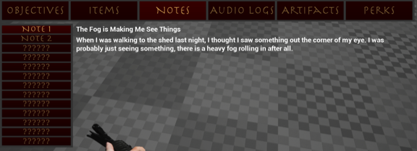

***Figure 1.2-8. Item Menu***

Pause Menu:

This menu will let the player save or load a game, view and change settings, exit to the main menu, and exit the game.

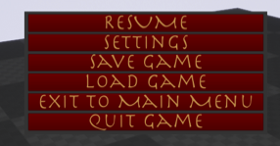

***Figure 1.2-9. Pause Menu***



**Section 2 System & Object Design**



* 1. **Introduction**
     1. **Purpose**

The purpose of this document is to outline and summarize the systems, structures, and objects of Project Night Terror. It is important to note that as a game, there are very many structures involved. In response, this document will outline major classes, structures, and objects. It is also important to note that an Unreal Engine 4 Blueprint is a type of representation for classes and the classes will be created through blueprints instead of C++ text code.

* + 1. **System & Component Overview**

The purpose of the diagram in Figure 2.1-1 is to show how different parts of the game relate and connect. This will help aid in understanding where some of the many figures are located and/or work together.



***Figure 2.1-1. Component Overview***

* 1. **Class Diagrams**

**2.2.1 Purpose**

The purpose of the class diagrams below is to reduce the amount of unneeded code duplication; increase the use and ease of modularity by utilizing inheritance; and to assist in decreasing the time that is required to make new features and classes. Unreal Engine 4 greatly assists and makes it easier to create and use child classes by having a quick command to create them. The engine also makes it very easy to change parent classes as any changes are immediately and seamlessly added to the children with no additional work. Accessing the parent classes also helps to reduce unneeded code. For example, instead of needing to call the fire function specifically from the rifle class or the pistol class, the parent base *Gun* can be called instead with no regard to what weapon is actually being used.

**2.2.2 Characters**

Characters are any class that is humanoid or has AI behaviour to it. Most of the characters in the game are interactive and can interact with the player or other characters in some way. Demons can attack and be attacked by the player and a specific human character; the specific human character can attack the demons; and finally the player themselves who can attack or be attacked by demons. Along with these characters there are non-interactive characters that do not have the same abilities and will just roam the environments. The only exception to this is the main ghost who will, indirectly, guide the player character.

Each of the characters can move and have specific movement animations associated with that specific character. Each character also has a specific set of components and skeletal mesh. Interactive characters have additional functionality most commonly with their attacks and their variable health.



***Figure 2.2-1. Character Class Diagram***

**2.2.3 Pickups**

Pickup classes are any form of pickup that the user can encounter in the game including story pickups, ammo, and health. Aside from each pickup having a name, each pickup has a similar destroy function that will remove it from the level once the player character has picked it up. The main difference between common leaf nodes is the model used for specific classes. Ammo pickups increase the player’s current ammo for a specific weapon; health pickups increase the player’s health; story pickups include notes, artifacts, audio logs, and upgrades.



***Figure 2.2-2. Pickup Class Diagram***

**2.2.4 Weapons**

Weapon classes are split into two main categories, guns and melee. All weapons require their own set of animations when used by the player and also their own static mesh. Gun classes require a fire and reload functions and their own variables such as magazine size, accuracy reload speed. Melee weapons are weapons that the player uses in close combat with the demon characters. These require an attack range, as the demons should only take damage when they are a certain range from the player and when they are struck by the specific melee class. Currently, the difference between gun leaf nodes and between melee leaf nodes do not have any specific difference other than the ones already mentioned.



***Figure 2.2-3. Weapon Class Diagram***

**2.3 Flowchart Structures**

**2.3.1 Purpose**

Flowcharts help to assist in visualizing how the game runs from start up to closing and to also visualize the flow of AI behaviour from one state to another and the in workings of a state itself. This helps to clarify workflow and to assist in debugging/testing purposes.

**2.3.2 General Game Flow**

The most general, but always used flow is the overview of the game shown in Figure 2.3-1 below. All players will have to start by opening the game, which brings them to the main menu. From there, the player has the option to delete saves, load a save, exit the game, or start the game from the beginning. Once in normal gameplay, the player has similar options, but will usually return to the same normal state. When a level is completed the game is saved and the next level is loaded. Once the game is finished, the player will be shown the credits, and will finally be sent back to the main menu.



***Figure 2.3-1. Basic Flowchart of the Game***

**2.3.3 Demon Behaviour State Flow**

All demon characters follow the same general flow. Upon begin play, the demon will either stand idle or will randomly walk to a randomly picked location within a navigation-bounded area. Upon seeing the player, the demon will move so they are in range with the player; if the demon is a ranged character they will stop further away from the player and will stop closer if they are a close combat demon. For example, light demons, the main demon, and the priest all have ranged attacks while the heavy demon and beast characters have short ranged attacks. Many of the checks to attack and to move are updated with each event tick.



***Figure 2.3-2. Demon Flowchart***

**2.3.4 Ghost Behaviour State Flow**

Both the general ghost characters and the main ghost character follow a very similar flow within their states. Both sets of characters will have a location that they will either currently be at or one that they need to randomly select or have preselected and move to. This will continue indefinitely for the general ghost characters and will stop for the main ghost when she has reached her final predefined location.



***Figure 3.4-1. Main Ghost Flowchart***



***Figure 2.3-3. General Ghost Flowchart***

**2.3.5 Saving & Loading**

Loading the game is very simple. The loading function checks to see if there is a save file and will do nothing if there is no file. If the function does find one, then the save is opened, and the variables in that file are stored into the current game variables.



***Figure 2.3-4. Loading Flowchart***

Similar to loading, the save function for the game is very simple. The saving function checks to see if there is a save file and will create a new one if there is no file. If the function does find one, then the player will be asked if they want to overwrite that current save. If the user selects no then the game is not saved and nothing happens. If the user chooses yes then the save is opened and the current in game variables are saved to the save file.



***Figure 2.3-6. Saving Flowchart***

**2.4 Perk Trees**

**2.4.1 Purpose**

Throughout the game players collect upgrades to enhance their character in different categories. The different areas are: health, flashlight, pistol, rifle, cross, and knife. The player can select any perk they want as long as all prerequisite parent nodes have been unlocked. Initial nodes in the tree can be chosen with no prerequisite nodes required. For example, in Figure 2.4-1node 1 and node 2 can be chosen right away. However, node 3 can only be chosen once node 1 has been previously chosen. Node 4 can only be chosen once node 1 and node 2 have been previously chosen.



***Figure 2.4-1. Perk Tree Example***

For the scope of this project, only perks for health, the flashlight, the pistol, and the rifle will be implemented. Perks for the cross and knife will be created or implemented currently.

**2.4.2 Health**

The health perk tree consists of 5 nodes shown in Figure 2.4-2. These nodes include permanent health increases to the player and also increases to the health gained from health pickups. *Health Increase 1* and *Health Increase 2* increases the player’s maximum health by 25 and *Health Increase 3* increases it by another 50. *Health Pickup 1* and *Health Pickup 2* increases the amount of health gained by 10 each.



***Figure 2.4-2. Health Perk Tree***

**2.4.3 Flashlight**

The flashlight perk tree consists of 6 nodes shown in Figure 2.4-3. *Battery Capacity 1, Battery Capacity 2,* and *Battery Capacity 3* increases the flashlight maximum charge by 25, 25, and 50 respectively. *Efficient Batteries 1 and Efficient Batteries 2* decrease the speed that the flashlight runs out of power by 0.25s each. Finally, *Limitless Power* allows the user to have the flashlight on for as long as they want without having to recharge it.



***Figure 2.4-3. Flashlight Perk Tree***

**2.4.4 Pistol**

The pistol perk tree consists of 6 nodes shown in Figure 2.4-4. *Pistol Damage 1*, *Pistol Damage 2*, and *Pistol Damage 3* increases the damage dealt by the pistol by 10% each. *Pistol Magazine 1, Pistol Magazine 2,* and *Pistol Magazine 3* each increase the magazine size of the pistol by 2.



***Figure 2.4-4. Pistol Perk Tree***

**2.4.5 Rifle**

The rifle perk tree consists of 6 nodes shown in Figure 2.4-5. *Rifle Damage 1* and *Rifle Damage 2* increases the damage dealt by the rifle by 5% each. *Rifle Reload 1* and *Rifle Reload 2* decreases the time it requires to reload the rifle by 5% each. *Rifle Magazine 1* and *Rifle Magazine 2* each increase the magazine size of the pistol by 2.



***Figure 2.4-5. Rifle Perk Tree***

**2.5 Blend Spaces**

**2.5.1 Purpose**

A blend space is used to create smooth animation transitions for characters when certain variables are constantly being changed or updated. In this application, all transitions are based on the character’s speed and direction. The blend spaces are used alongside state machines that, given the character’s direction and speed, will play a specific animation. Animations are added to discrete points on the blend space graph so the state machine knows which animation to use based on the variable input described above. If the variables are not on one of those specific points then the animation that is used will be a blend of nearby animations that creates a smoother transition.

**2.5.2 General Blend Space**

All character blend spaces follow the same variables, coordinate system, and general animation set up. The animations will be slightly different depending on what the character is currently doing and who the character is. For example, the main player character will have multiple blend spaces for each item they have equipped, as the animations will be different. The player will still have the basic animations in the same locations (walk, walk left, walk right, etc.), but the animations will reflect the item they have such as holding a rifle would use rifle walk, rifle walk left, rifle walk right, etc. in place of walk, walk left, walk right, etc.

The blend space is set up as shown below in Figure 2.5-1 and it is important to note that the top of the speed axis is the top speed of the character and is not 20. This value was used to show the points better. When the speed is 0, the character is not moving and all is idle. When they reach a speed of 10, the character is wholly using a walk animation either forward, right, left, or backwards given their direction. Finally, if the character is moving at full speed, they will be running in similar directions as they would if they were walking. If the character is at any point other than the ones shown discretely below, then the animation that is used will be a blend of surrounding animations points. The discrete points are outlined in Table 2.5-1.



***Figure 2.5-1. General Blend Space Graph***

***Table 2.5-1. General Blend Space Points***



**2.6 State Machines**

**2.6.1 Purpose**

The state machines described below allow the characters to move from one animation state to another. The state machines allow for better and smoother transitions created by blend spaces. This also allows separation and use of unique animation subsets such as normal movement blend spaces versus movement with a weapon blend spaces.

**2.6.2 Main Character**

The main player character has multiple sub state machines that make up one large machine to reflect the items that they are currently using. The main state machine, only showing the sub state machines and the transitions is shown in Figure 2.6-1. The transitions between these sub states are controlled by an equipped integer variable that updates when the player swaps between items or has no item equipped. It is important to note that all sub state machines can enter the *Die* state at any point and does not need to transfer to other states first. It is also very important to note that although not planned or intended, the main state machine is a pentagram; this is very fitting for the feel and mood of the game. Laudate satanico sint status machine.



***Figure 2.6-1. Main Character Main State Machine***

When no item is equipped, the player uses the default Walk-Run sub state machine shown in Figure 2.6-2. This allows the game to display the correct animations while the user is walking, running, or idle.



***Figure 2.6-2. Main Character Walk-Run Sub State Machine***

When the rifle is equipped, the player uses the rifle sub state machine shown in Figure 2.6-3. This allows the game to display the correct animations while the user is walking, running, or idle with a rifle. The rifle also utilizes reload and fire states for additional animations. These two states do not have blend spaces associated with them as character speed and direction will not impact the animations. A very similar state machine is used for the pistol since the actions the player goes through are the same. The difference between the pistol sub state and the rifle sub state are the blend spaces and animations used. The guns can go directly from the idle or the walk-run states into the reload or fire states and vice versa back into the defaults when no action is taken place. The function finished conditions shown are to get back to idle and walk-run states.



***Figure 2.6-3. Main Character Rifle & Pistol Sub State Machines***

When the cross is equipped, the player uses the cross sub state machine shown in Figure 2.6-4. This allows the game to display the correct animations while the user is walking, running, or idle with a cross. The cross also utilizes an attack state for an additional animation. This state does not have a blend space associated with it as character speed and direction will not impact the animation. A very similar state machine is used for the knife since the actions the player goes through are the same. The difference between the cross sub state and the knife sub state are the blend spaces and animations used. The attack state can be accessed from either idle or walk-run states and access is bidirectional.



***Figure 2.6-4. Main Character Cross & Knife Sub State Machines***

**2.6.3 Demon Characters**

All demon characters follow the same general state machine. The demons will stand idle when finding a new location, walk when the location is found, move to the player when the player is close enough, begin to attack the player, or die if their health drops equal to or below 0. These five specific states are shown below in Figure 2.6-5.



***Figure 2.6-5. Demon State Machine***

**2.6.4 General Ghost**

All general ghosts follow the same state machine and is only two states large. This is due to the ghosts not interacting directly with the player or with other characters. The two states are an idle state where the character will pick a new location to move to and a random walk state where the character will move to the random location. This will go on indefinitely.



***Figure 2.6-6. General Ghost State Machine***

**2.6.5 Main Ghost**

The main ghost’s state machine is only two states large. This is due to the ghost not interacting directly with the player or with other characters. The two states are an idle state where the character will pick a new location to move to based on predefined locations and a walk state where the character will move to that location. This will continue until the character has reached its final destination.



***Figure 2.6-7. Main Ghost State Machine***



**Section 3 Test Plan & Execution**



**3.1 Introduction**

**3.1.1 Purpose**

The purpose of this section is to outline and summarize the testing processes used for Project Night Terror. The focus of the testing will be to ensure gameplay and functionality for the player works well, is desirable, usable, and playable. The testing will also help to fine tune variables involved with the player and Non-Playable Characters (NPCs).

It is important to note that there is a lot of minor and quick testing done during development as added functionally and minor changes are always tried before moving on. By doing this, I am able to detect and fix problems or bugs sooner. This also allows fine-tuning some variables better earlier on. Problems or bugs that are not resolved right away will often be left till later, but will be documented in GitHub under issues. This section will not show every case test and the appendices and GitHub issues/documents should be refereed to for more information.

**3.1.2 Things to Test**

**Gameplay**

Gameplay includes player movement (such as jumping, running, etc.) and anything not listed below.

**AI**

Testing for AI is to test every NPC. This will involve testing that animations flow well; testing that AI will respond and attack properly; that the AI will roam properly and in predefined bounds; and testing specific AI variables such as health, damage, and that attack speed are working properly. The testing methods used to test the AI will include black/white box testing and also usability testing.

**Items**

Item testing includes the user’s flashlight, rifle, pistol, knife, and cross. The purpose of testing items is to ensure that the game does not become too easy or hard with bad variable values or mechanics; to ensure that animations and general look of items makes sense and looks good; and to ensure that the items follow good general usability ideas. This will be done with black/white box testing and also usability testing.

**Collectables**

Testing the collectables includes ensuring that their text displays properly, that audio files play properly, and that picking them up adds to the player’s inventory properly. This will mostly be done with white box testing, but usability testing will also be used.

**Saving & Loading**

Testing saving and loading is important so the user can save and leave the game; so the user can come back to the game and pick up where they left off; and to ensure that the player’s progress is saved while moving across levels. There are many different variables that need to be saved or loaded and white/black box and usability testing will be used to test it.

**Levels**

Level testing includes going from one level to the next, ensuring that there are little to no bugs in map design (such as clipping, level holes, lighting issues, etc.), and to ensure that level traversal by the player is smooth (for example, stairs should by walked on without getting stuck). This will be done usability testing and black box testing.

**User Interfaces**

User interfaces (UI) include the heads up display (HUD), the main menu, pause menus, item menus, and the sub menus within these. It is important to see if the interfaces are visually appealing, if the functionally works, and if usability is present.

* + 1. **Test Level**

A test level, that is not accessible to the player, was created very early in development to allow quick and easy testing. From early movement to working with AI, the testing map allows a large multitude of functions and features to be tried, displayed, refereed to, and more. The test level also saves time by not having to move parts that would need to be moved on a playable level or by having to build the level’s lighting. Finally, there is no reason to remove items from the level as the different parts can be added to specific areas and left until needed or indefinitely. Figures 1.3-1 to Figure 1.3-3 show samples of the test level. It is important to note that features in the testing level may or may not be used in the game and is often where unused features can be seen. For example, in Figure 1.3-3 the area used to test demon AI was originally designed to view and see wooden ramps, hedgehogs, and other parts of the Atlantic Wall from WWII; a level that was originally planned early in development, but scraped in the first few months of development.

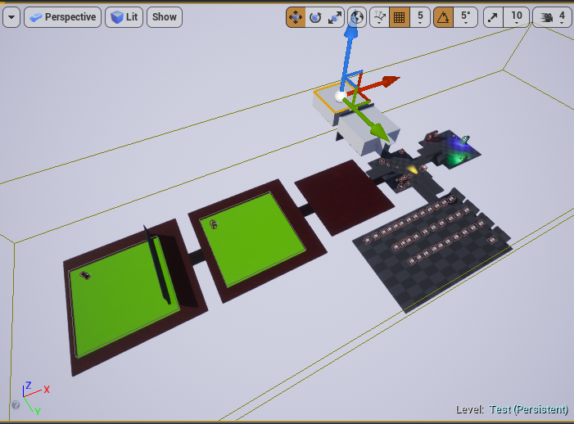

***Figure 3.1-1. Entire Testing Level***

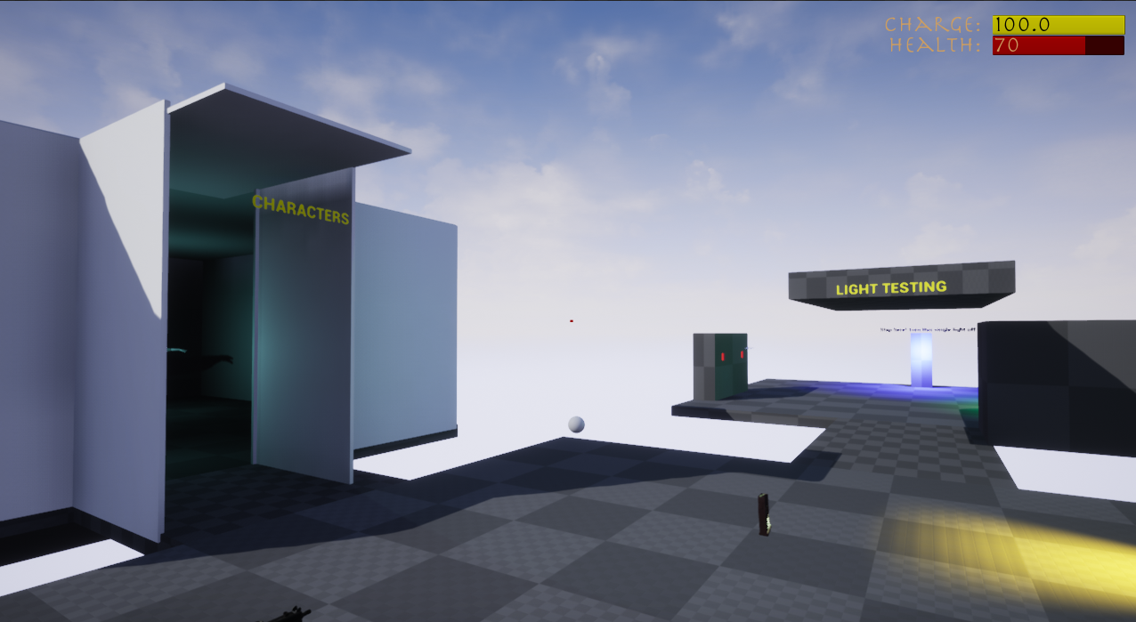

***Figure 3.1-2. Test Level: Character & Light Areas***

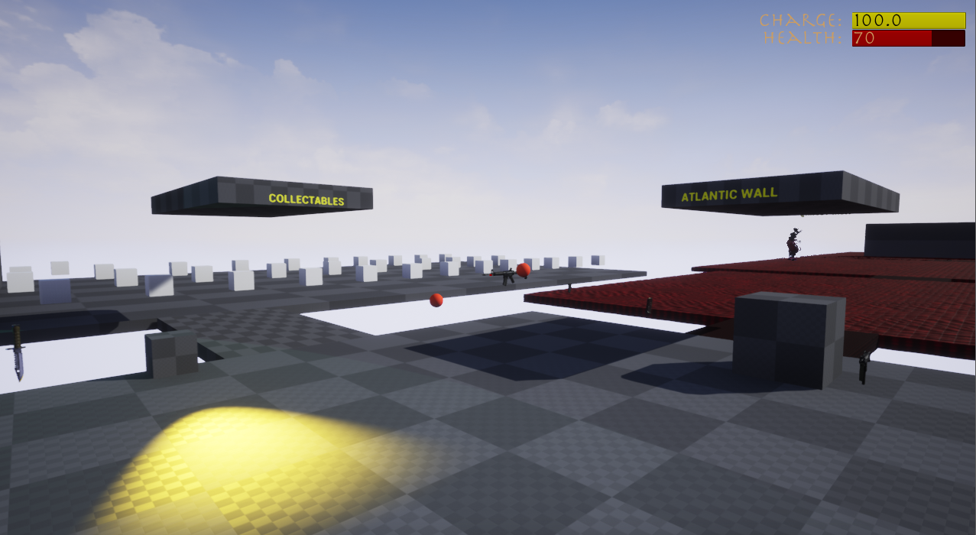

***Figure 3.1-3. Test Level: Collectables & Modified Atlantic Wall Areas***

**3.2 Usability Testing**

**3.2.1 Purpose & Breakdown**

The purpose of usability testing is to ensure that a range of users find the game usable, playable, and desirable. It is important that the user can learn the game easily and that the game is not hard due to controls, bad functionality, bugs, etc. Usability testing can help alleviate concerns or problems that may not arise during development and can create a better final product.

A usable game is one that the player can learn the controls without frustration and can easily understand them. A playable game is one that has few or no bugs, is not too difficult for the majority of players, and is enjoyable to play. Finally, a desirable game is one with nice user interfaces, good player interactions (such as shooting, reading text, using menus, etc.), and looks good overall.

Potential testers will be requested and any testers will be asked to fill out a consent form. Next, the tester will fill out a demographic questionnaire that will give insight into the tester’s information, but more importantly their brief history with video games. The tester will then play different parts of the game and give feedback during the play test if they wish. Once playing is finished, the tester will fill out a post-questionnaire about their experience and provide feedback based on their experience.

**3.2.2 Demographics**

It is important for Project Night Terror to be playable and appealing to a large demographic. However, the game does not have a specific demographic so the testing does not have any particular demographic to test for either.

**3.2.3 Testing Results**

**3.3 White Box Testing**

**3.3.1 Purpose & Breakdown**

The purpose of white box testing where the tester knows about the code behind the tests is to fine tune the game, fix bugs and problems as soon as they arise, and to ensure that common events that the user will encounter are tried. There was no specific tool used in this type of testing as it was all done inside the engine. The tests were created, performed by playing the game, and the functions being tested were improved based upon the results. Table 3.3-1 below shows the different areas were white box testing was used. Brief overviews of the areas that need to be tested are below as well.

**Guns**

All guns need to be tested to for firing and reloading. The weapon should only fire when the player has ammo, when the player has ammo in the magazine, and when they are not reloading. The weapon should only be able to reload when the player has ammo to reload and the magazine is either empty or not full. Shooting should also be accurate enough to give the player a realistic shooting experience.

**Melee Weapons**

Melee weapons need to be tested to check if attacking works by dealing damage and can only deal damage when the user is within a specific range from a demon.

**Flashlight**

As a core item in the game, the flashlight must be able to charge and lose charge at a constant rate. The flashlight must be off when it has no charge and on if the player choses to turn it on and there is a charge. Other features such as damage or effects to the demons also need to be tested.

**AI**

The AI must be able to attack the player and also deal damage to the player. The combat between the player and AI can be tested while testing multiple cases for the weapons, character, and AI itself.

**Pickups**

Ammo and health pickups should properly add to the player’s health or ammo only if those values are not currently maxed. If ammo or health is not maxed then the pickup increase should cause the player’s ammo or health to become their current amount plus the pickup amount or it should become the maximum amount if the difference is less than the pickup amount.

**Saving**

All player and level related variables and information must be saved when the player selects the save button. The player information also needs to be saved between levels or information will be lost when a new level is loaded. Saves must also be checked that they properly delete when the user wants to delete a save file. If it is not properly deleted than there will be unexpected results with loading.

**Loading**

All saved variables need to be checked upon loading to ensure that the proper player and level information is being updated when the player wants to play from a save. If a load is not properly implemented then the information lost could result in the player not having an item at that point, such as the flashlight in the last level, or a level may destroy an actor that it believes the player already has found.

**Perks**

Checked alongside item testing and health checks, when perks are selected the related variables and values are properly updated visually and in the back end.

**Objectives**

Tests need to check if objectives are being updated when specific tasks are completed such as completing a level, upon a level loading, or when a user picks up an objective related item. Without these tests, if an objective does not properly update then the user may become frustrated or confused. Objectives are critical as they are the main drive for the player on what to do or where to go. Levels are also designed to move to the next once all objectives are completed so a missed or bad test could create an instance where the player is unable to advance in the game.

***Table 3.3-1. White Box Testing List***



**3.3.2 Tests Performed**

Although a lot of testing is performed as the game has been developed, there are some specific tests performed on features such as the items. The rifle, pistol, cross, knife, and flashlight have been tested for boundary values and specific cases. For example, the rifle’s and pistol’s reload function needed testing to ensure that the could not reload if they have a full magazine or if they do not have enough ammo to fill the clip. On top of this, the reload function has the potential to affect or read the specific weapon’s total ammo, current magazine amount, and max magazine size. By checking specific cases, the reloading function was improved and situations that the player would commonly encounter, such as reloading at any point not just when the magazine is empty have been check to ensure there is no error. The rifle reloading testing table is shown in Table 3.3-2 and other item testing tables are shown in Appendix A.

***Table 3.3-2. Rifle Reload Function Test***



**3.4 Black Box Testing**

**3.4.1 Purpose & Breakdown**

The purpose of black box testing is to find problems that may not include code or does not require knowing the system behind the feature. For example, searching for a hole in the map requires no understanding on why or how that hole is there. This is important as there are gameplay elements or parts of the game that could affect the player’s experience if not found, tested, and/or resolved. Although many black box tests are covered by usability testing, it is important as the developer to ensure that all test cases in Table 3.4-1 are properly covered.

**Pickups and Visuals**

Tests that require a check for pickup need to ensure that the player can properly pick it up, that the item is destroyed, and that the item is added to the player’s inventory. For example, a note should prompt the user to pick it up then, upon the proper user action the note should disappear from the level and its information become visible to the player in the in game menu. Pickup checks go hand in hand with visual or audio that the user will hear or see since it is only available until after the user picks the item up or after a specific task is completed.

**Lighting**

Lighting tests are important as a level that is too dark can make a player frustrated that they cannot see; other problems such as strange or unrealistic reflections and shadows can also cause the player to have a lower quality experience.

**Player Movement and Controls**

Bad player movement, awkward controls, etc. can frustrate players, leave them confused, or lower player experience. Black box testing helps alleviate these concerns by checking player speed, animations, control placement, and more. Although listed in black box testing, this will be mostly covered in usability testing, as the testers will be covering these cases.

**Menus**

Menus need to work as intended and checking every single button in multiple ways ensures that the functionally properly works. Although most cases would be covered by the usability tests, the testers may not check every button or menu, which will leave specific parts untested. To avoid the lack of coverage, developer testing will include trying every user interface element.

**Characters**

The AI characters will need to be watched visually to check and see if they roam to places that were unintended such as out of bounds of the map, into level holes, etc. Since this does not relate to the actual functionality or code and is just visual, the only adjustments that testing will do to the characters will be level placement changes to the landscape, navigation bounds, BSPs, or static meshes.

***Table 3.4-1. Black Box Testing List***



**3.5 Automated Testing**

**3.5.1 Purpose & Breakdown**

Automated testing could lower the time it would take to test certain functionality of the game. However, there currently is no plan for automated testing as there is nothing deemed beneficial to test automatically as almost all functionally and gameplay will be done by the user. It would be more beneficial to have myself or others see the testing first hand to give more insightful feedback. If automated testing is added, it will be added here.



**Section 4 Business Plan**





**Section 5 How-To-Use**



**5.1 Introduction**

**5.1.1 Purpose**

The purpose of the how to manual is to explain how to use the different parts of Project Night Terror and what type of hardware is required to run it.

* 1. **Hardware Specifications**

**5.2.1 System Requirements**

Project Night Terror must be run on a personal computer or laptop. Since the game was created on a MacBook, the game would be better suited for Mac users. The user’s computer must have at least 2Gb free to be able to store the game. It is suggested that newer or higher powered computers run the game for optimum performance. Lower quality graphics cards, RAM, etc. can cause the game to have performance issues.

**5.3 Gameplay Menus**

**5.3.1 Menus**

Project Night Terror has 3 unique menus that the player will see: the Main Menu, the Pause Menu, and the In Game Menu. The main menu is what the player will see when the game is loaded and the player is able to start a new game, load a previously saved game, delete the saved game, open settings, view the credits, or exit the game. This menu is shown below in Figure 5.3-1.

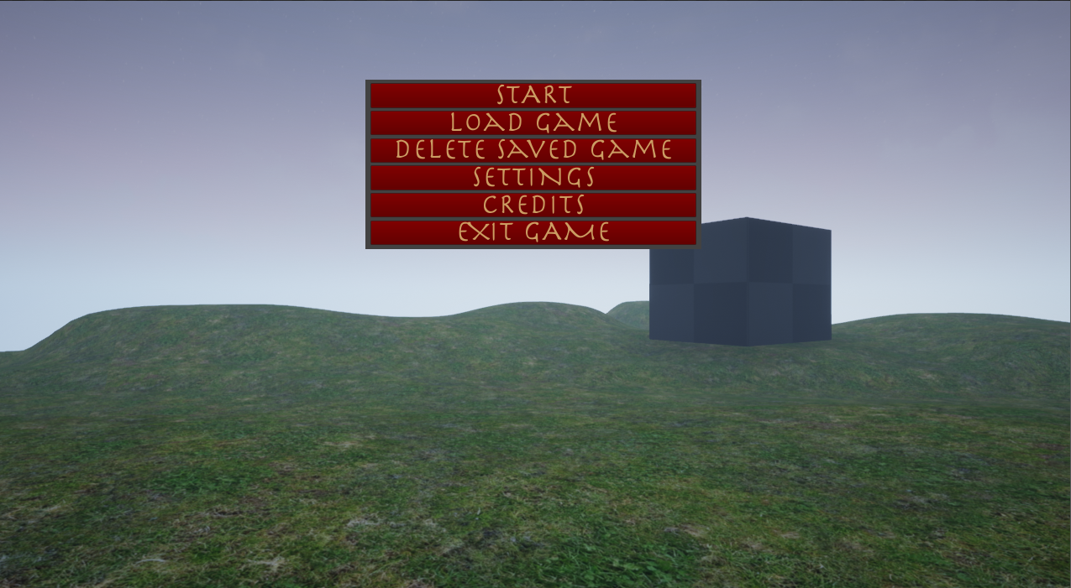

***Figure 5.3.1-1. Main Menu***

The pause menu, shown below in Figure 5.3-2 can be opened by pressing *P* anytime while in game and not on another menu. To leave the pause menu, simply press *P* again. From the pause menu, the player can load from the save file, open the settings, exit to the main menu, or exit the game. The player can also close this menu by clicking on “Resume”. When pressing “Settings”, the settings menu will appear and the user will be able to interact with it in a similar way. To return back to the pause menu, simply press the back button while on the settings menu.

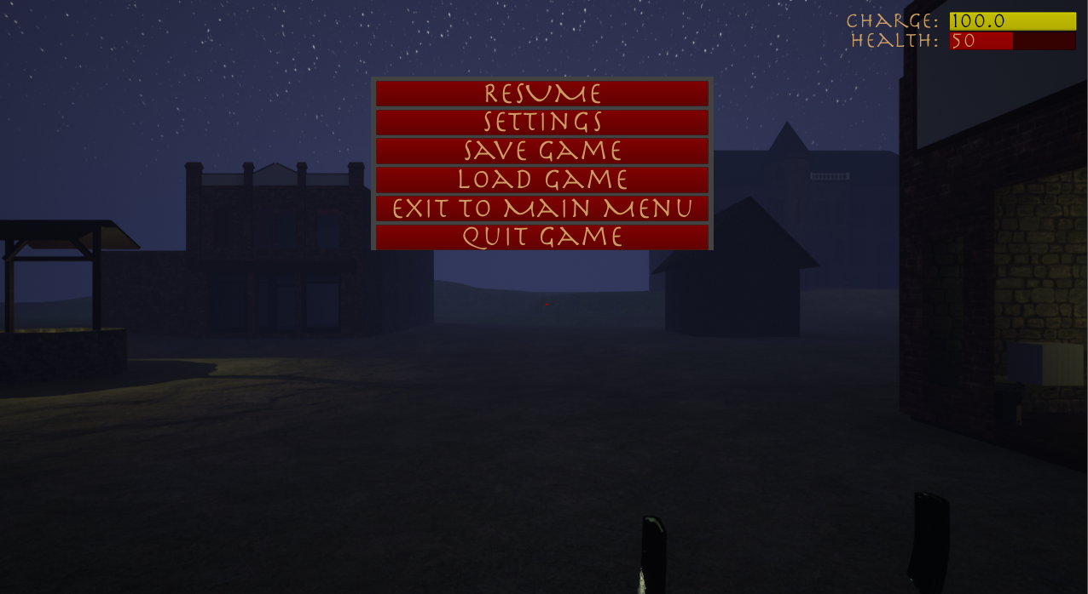

***Figure 5.3-2. Pause Menu***

To access the in game menu shown in Figure 5.3-3, press *I* anytime while playing the game and not on another menu. To leave the in game menu, simply press *I* again. From the in game menu, the player can navigate to different tabs to see descriptions and information about objectives, items, notes, audio logs, artifacts, and perks. Whenever the in game menu is opened, the objectives tab will always be displayed first. The information and navigation of these tabs are explained further below.

Project Night Terror also has other minor menus such as the settings menu and the credits menu. These are easier to understand (such as the credits menu only having a back button) so this document will not cover them, but will instead make a mention of them.

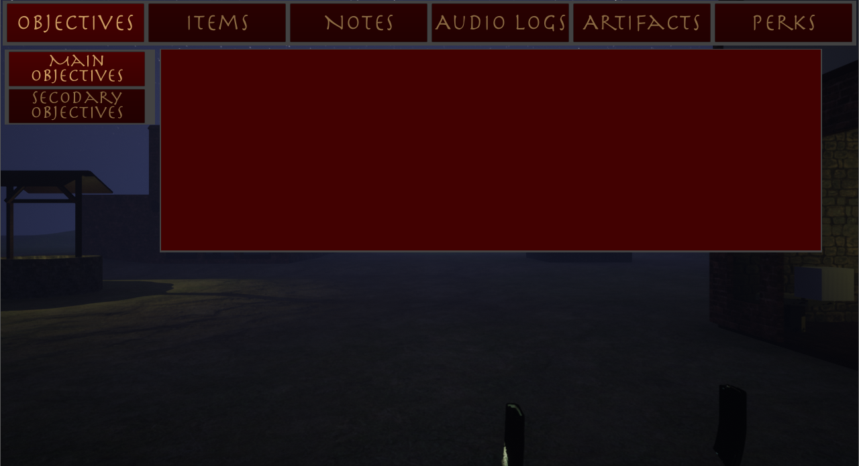

***Figure 5.3-3. In Game Menu***

**5.3.2 Objectives Menu**

Objectives are split into main objectives and sub objectives, but both can be viewed from the in game menu. When an objective is updated “Main Objective Updated”, “Sub Objective Updated”, or “Objectives Updated” will be displayed in the top left corner of the screen. To view objectives, press *I* to open the in game menu and select either “Main Objectives” or “Sub Objectives”. If there are currently no sub objectives, then the objective will not show anything. Figure 5.3-4 below shows this screen.

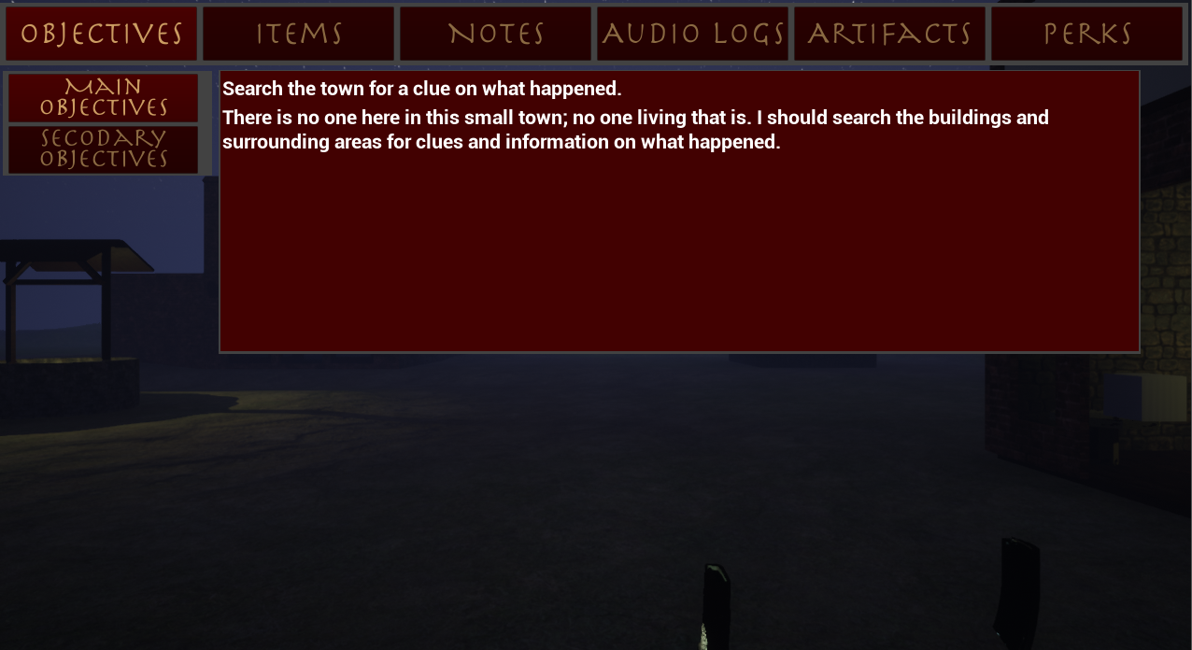

***Figure 5.3-4. Objectives Tab with Main Objectives Selected***

**5.3.3 Items Menu**

The item menu displays information about items that the player picks up and can use including the flashlight, rifle, pistol, cross, and knife. Once an item has been picked up and obtained, the player can go to this menu by pressing *I*, clicking on “Items”, then clicking on the specific item for its description. If an item has not been unlocked yet, the button will show “??????” and the player will be unable to select it. To exit the in game menu, press *I*. The Item menu is shown below in Figure 5.3-5.

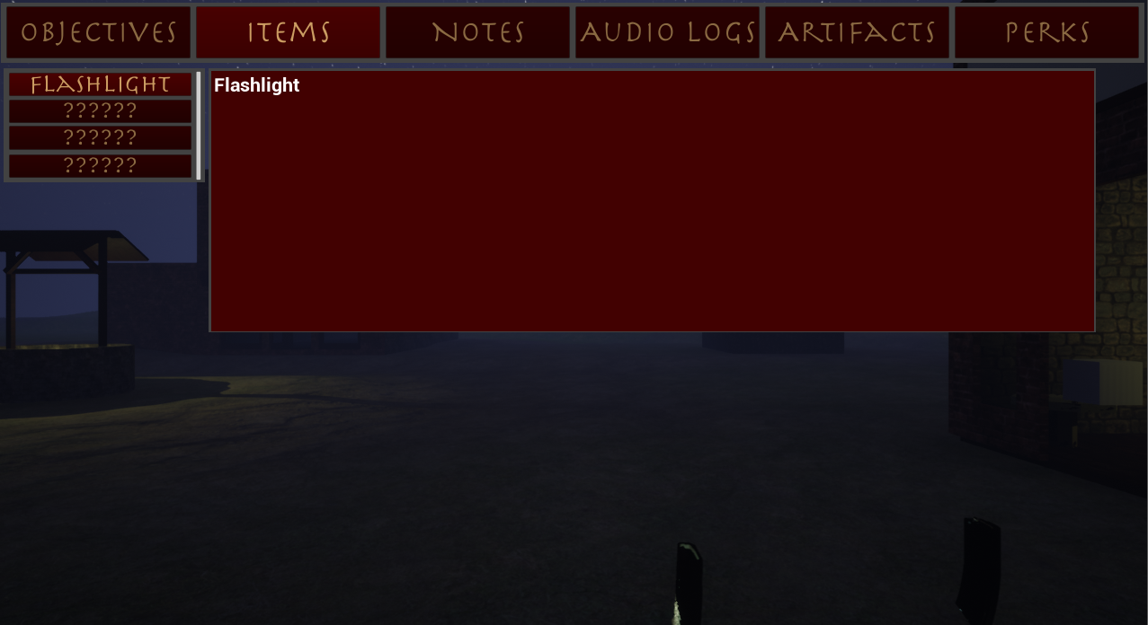

***Figure 5.3-5. Items Tab with Flashlight Selected***

**5.3.4 Collectables & Other Pickups**

In every level, there are four unique styles of collectables that the player can pickup; notes, audio logs, artifacts, and upgrades. The total number of a specific collectable in a level may be different than other levels. To pick up a collectable, approach it and when prompted, press *E;* shown in Figure 5.3-6. This will add the collectable to the player’s inventory. Upgrades do not have a specific menu, but instead will increase the number of perks that the player can unlock by 1 shown on the perk menu.

To view the collectables that the player has picked up, press *I* to get to the in game menu and then click on “Notes”, “Audio Logs”, or “Artifacts”. From any of these menus select a specific note to read its description or in the case of an audio log, also listen to it. To leave the menu, press *I*. Before selecting a specific collectable and after is shown in Figure 5.3-7 and 5.3-38 respectively.

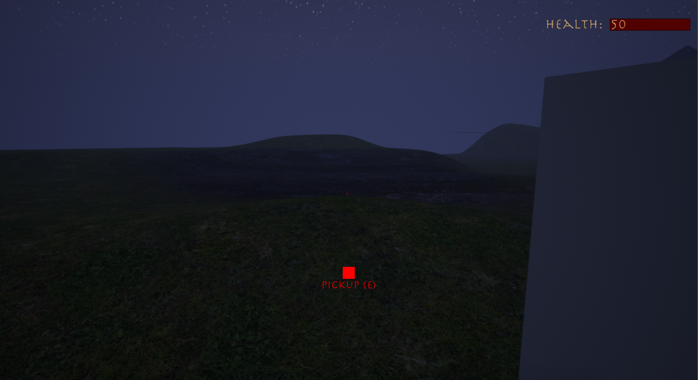

***Figure 5.3-6. Collectable Pickup Prompt***

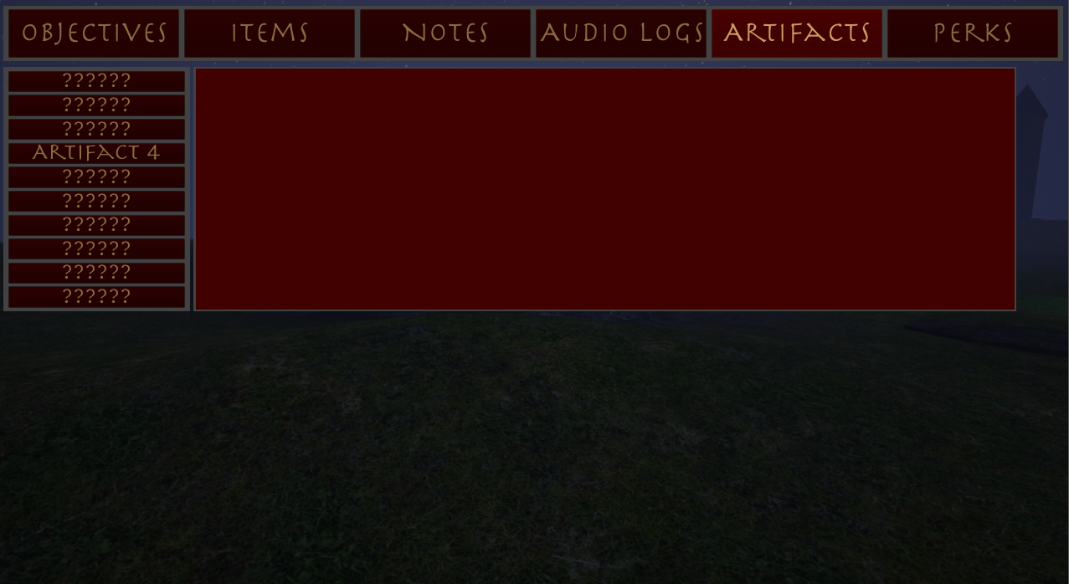

***Figure 5.3-7. Artifact Menu Before Selecting Artifact 4***

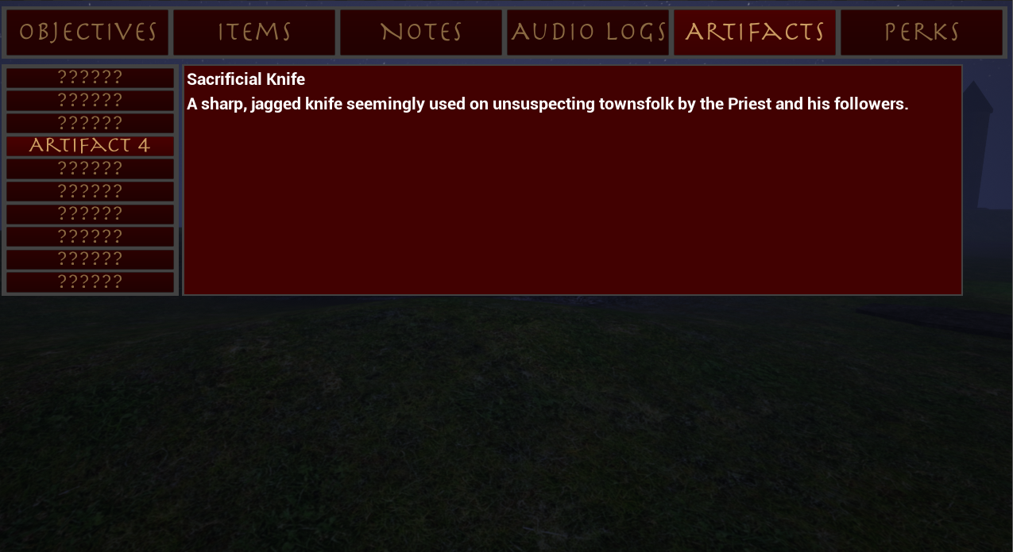

***Figure 5.3-8. Artifact Menu After Selecting Artifact 4***

**5.3.5 Perks Menu**

Once an upgrade has been collected, press *I* to get to the in game menu and then click on “Perks”. The perk menu is shown below in Figure 5.3-9. From this menu, the player can select any perk to read a short description about it. When the player is ready to choose a perk, they select it and then click the “Confirm” button. If the player does not have any upgrade points then the perk will not be applied. Also, the player must have all parent nodes of a branch unlocked to be able to choose a perk. If the prerequisite nodes are not already unlocked, the perk will not be unlocked.

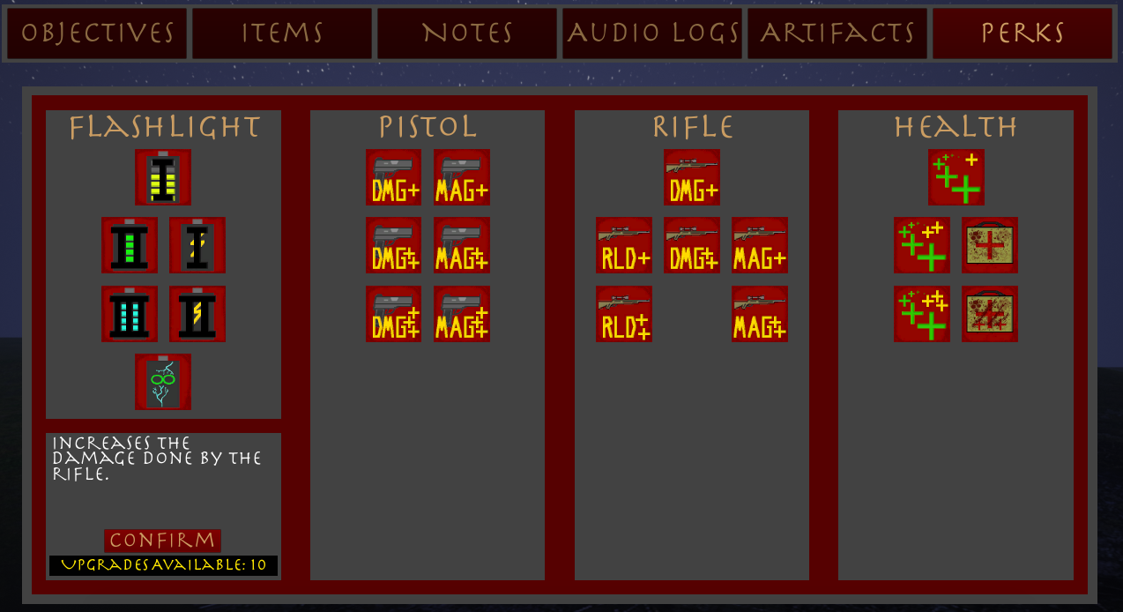

***Figure 5.3-9. Perk Menu***

**5.4 Normal Gameplay**

**5.4.1 Button Mappings**

Figure 5.4-1 shows the button mappings of Project Night Terror. There is currently no option to change these configurations inside the game.

***Table 5.4-1. Button Mapping***



**5.4.2 Attacking**

Throughout the game, the player will find and pickup different weapons to use against the demons in the game. Once a weapon has been found and picked up, the player can press *2* to use the rifle, *3* to use the pistol, *4* to use the cross, or *5* to use the knife. When an item is equipped, the player can use it by clicking the left mouse key. If the player presses *1* then any equipped item will become unequipped.

As opposed to melee weapons, the rifle and pistol will fire and can attack demons at a distance. The player must reload their weapon by pressing *T* when they have run out of magazine ammo. There is a slight delay in reloading and during this time the player cannot fire their weapon. Once reloading is finished, the gun can be fired again. If the player has no ammo, then they will be unable to fire their weapon and must find more to use it again.

To attack with the cross or knife, the user must move close to a demon. This distance is dependent on the item currently equipped; the cross has a further reach and the player can be a bit further away from demons to use it than the knife. Once close enough, the user can begin to attack and the demon will begin to take damage. The player can attack the demon as many times as they want while using a cross or knife, but there is a small delay between strikes.

**5.4.3 Saving & Loading**

When a level is completed or a new game is started, the game is automatically saved for the player. However, to save manually open the pause menu by pressing *P* then click the “Save” button. Once saved, “Game Saved” will appear in the top left corner of the screen. If a saved game does not exist, the game will automatically create one for the user. To delete a save, go to the main menu and select “Delete Saved Game”.

**WARNING: DO NOT TURN OFF THE COMPUTER OR EXIT THE GAME WHILE THE GAME IS STILL SAVING OR THE SAVE MAY BECOME CORRUPTED.**

To load a previous save open the pause menu by pressing *P* (if the player is at the main menu, they do not need to open the menu). Once the menu is open, click “Load Game”. If there is no saved file then the no game will be loaded and “No Save Exists” will show in the top left corner. If a save file does exist then game will be loaded for the player and “Game Loaded” will appear in the top left corner of the screen.

**5.4.4 HUD**

To keep the HUD (Heads up Display) simple, normal gameplay only shows the player’s health, the current charge of the flashlight, and a small dot in the middle to help with aiming, movement, etc. It is important to note that before the player has the flashlight, the charge information will not be visible. When either the rifle or pistol is equipped, that specific gun’s ammo information will be displayed along with the health and charge in the top right of the screen. Finally, when objectives are updated “Main Objective Updated”, “Sub Objective Updated”, or “Objectives Updated” will be displayed in the top left corner of the screen.

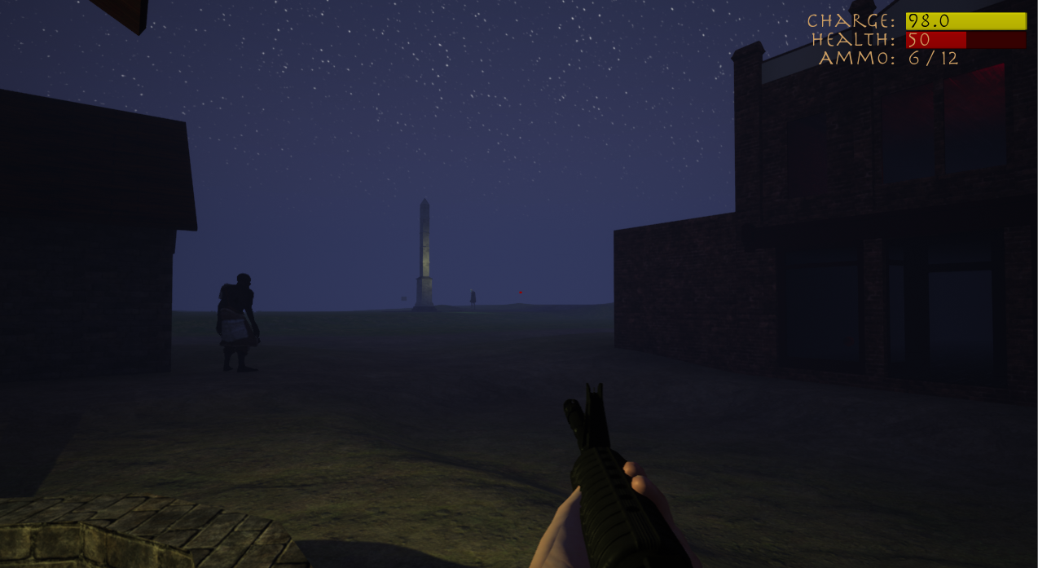

***Figure 5.4-1. HUD with Flashlight & Rifle Equipped***

**5.5 Startup & Exiting**

**5.5.1 Starting the Game**

To begin playing Project Night Terror, open the game executable file on the computer where it is saved or downloaded. This will start the game and will automatically have the game go into full screen mode. Once the game is opened, clicking “Start” will open a new game. To load a previously saved game, press “Load Game”.

**5.5.2 Exiting the Game**

To close Project Night Terror, open the pause menu by pressing *P*. Once the menu is opened, click *Exit Game*. This will close down the application and return the user to their desktop.



**Section 6 Log Book**





**Section 7 Conclusion**



**7.1 Conclusion**



***Figure 7.1-1***



***Figure 7.1-2***



**Appendices**



**Appendix B**

**White Box Tests**

**B.1 Rifle Tests**

***Table B.1-1. Rifle Reload Function Test***



***Table B.1-2. Rifle Fire Function Test***



***Table B.1-3. Rifle Pickup Ammo Function Test***



**B.2 Pistol Tests**

***Table B.2-1. Pistol Reload Function Test***



***Table B.2-2. Pistol Fire Function Test***



***Table B.2-3. Rifle Pickup Ammo Function Test***



**B.3 Cross Tests**

***Table B.3-1. Cross Attack Function Test***



**B.4 Knife Tests**

***Table B.4-1. Knife Attack Function Test***



**B.5 Flashlight Tests**

***Table B.5-1. Flashlight Function Test***



**Appendix C**

**Black Box Tests**

**C.1 Collectables Tests**

***Table C.1-1. Note Testing***



***Table C.1-2. Audio Log Testing***



***Table C.1-3. Upgrades & Perks Testing***



***Table C.1-4. Artifact Testing***





**Glossary**



**BSP**

**AI**

**UE4**

**UI**